**Final Report of Traineeship Program 2023**

*On*

***“VISUALIZING EXECUTIVE SALES”***

**MEDTOUREASY**



22th May 2023

**ACKNOWLDEGMENTS**

The traineeship opportunity that I had with MedTourEasy was a great change for learning and understanding the intricacies of the subject of Data Visualizations in Data Analytics; and also, for personal as well as professional development. I am very obliged for having a chance to interact with so many professionals who guided me throughout the traineeship project and made it a great learning curve for me. Firstly, I express my deepest gratitude and special thanks to the Training & Development Team of MedTourEasy who gave me an opportunity to carry out my traineeship at their esteemed organization. Also, I express my thanks to the team for making me understand the details of the Data Analytics profile and training me in the same so that I can carry out the project properly and with maximum client satisfaction and also for spearing his valuable time in spite of his busy schedule.

I would also like to thank the team of MedTourEasy and my colleagues who made the working environment productive and very conducive.

**TABLE OF CONTENTS**

Acknowledgments .................................... i

Abstract ..................................................... iii

|  |  |  |
| --- | --- | --- |
|  | | |
| **Sr. No.** | **Topic** | **Page No.** |
| **1** | **Introduction** |  |
|  | 1.1 About the Company | **3** |
|  | 1.2 About the Project | **4** |
|  | 1.3 Objectives and Deliverables | **7** |
| **2** | **Methodology** |  |
|  | 2.1 Flow of the Project | **7** |
|  | Platform Used | **8** |
| **3** | **Implementation** |  |
|  | 3.1 Gathering Requirements and Defining Problem Statement | **9** |
|  | 3.2 Data Collection and Importing | **10** |
|  | 3.3 Development of Dashboards |  |
| **4** | **Sample Screenshots and Observations** |  |
|  | 4.1 YTS KPI- The First Chart | **12** |
|  | 4.2 Sales- The Second Chart | **14** |
|  | 4.3 Profit- The Third Chart | **15** |
| **5** | Conclusion | **19** |
| **6** | Future scope | **19** |

**ABSTRACT**

The dataset's primary focus revolves around medical procedures, as indicated by the procedure ID, procedure date, and discharge date columns. These attributes can assist in understanding the timing and duration of specific medical interventions. By examining the procedure ID, medical professionals can identify the type of procedures performed, enabling them to analyze patterns and trends in healthcare practices. Additionally, the discharge date provides information on patient recovery periods, which can be used to assess treatment outcomes and resource allocation.

Examining patient data in conjunction with other attributes, such as region or country, can help identify patterns in healthcare utilization, patient outcomes, and disparities in access to medical services.

Financial aspects are captured through attributes like sales, discount, and profit. These columns provide insights into the economic dimensions of medical procedures. Analyzing sales data can help identify popular procedures and their associated revenues, facilitating financial planning and resource allocation. The discount attribute offers information on pricing strategies and their impact on sales volume. The profit column provides insights into the financial performance of different procedures and can guide decision-making to optimize profitability.

The dataset also includes additional attributes like segment and category, which can provide further insights into patient demographics, procedure types, and healthcare market segmentation. Analyzing these attributes can assist in understanding consumer preferences, tailoring marketing strategies, and optimizing resource allocation based on different market segments.

In summary, the provided dataset offers a comprehensive view of medical procedures, patient information, and financial aspects. Analyzing this dataset can lead to valuable insights into healthcare practices, patient outcomes, geographical patterns, logistical efficiency, and financial performance. The combination of medical, patient, and financial data allows for a holistic analysis that can inform decision-making, improve healthcare services, and optimize resource allocation in the medical field.

**About MedTourEasy**

MedTourEasy, a global healthcare company, provides you the informational resources needed to evaluate your global options. It helps you find the right healthcare solution based on specific health needs, affordable care while meeting the quality standards that you expect to have in healthcare. MedTourEasy improves access to healthcare for people everywhere. It is an easy to use platform and service that helps patients to get medical second opinions and to schedule affordable, high-quality medical treatment abroad.

**About the Project**

The project aims to create a custom dashboard in Tableau for MedTourEasy, a global healthcare company. The objective is to visualize and present key sales and profit insights to aid in decision-making and performance evaluation. The proposed solution will be built based on specific project requirements and will follow a step-by-step process.

The dashboard has a size of 1250px by 750px and will be structured using containers to ensure a clean and organized layout. It will consist of three charts displayed in a vertical container, with proper formatting and padding between them. Each chart will have a grey border, slightly darker than the pane background color, to enhance visual distinction.

The dashboard will feature four filters: Category, Sub-Category, Region, and Segment. These filters will provide relevant values to allow users to explore and analyze sales and profit data based on specific criteria. The title of the dashboard will be "Executive Sales," clearly indicating its purpose.

The first chart, titled "YTS KPIs," will display important key performance indicators such as Total Discount, Overall Profit, Total Quantity, and Total Sales. This chart will provide a comprehensive overview of sales performance.

The second chart, titled "Sales," will present monthly sales per year using an area chart. It will be formatted appropriately to ensure clear visualization and easy interpretation of sales trends.

Similarly, the third chart, titled "Profit," will showcase monthly profit per year using an area chart. It will be designed with proper formatting to highlight profit trends effectively.

Throughout the project, emphasis will be placed on professional formatting to ensure a visually appealing and user-friendly dashboard. The final solution will be presented as a comprehensive dashboard with all charts arranged in a vertical container, adhering to the general requirements and meeting the specific business requirements.

MedTourEasy is a global healthcare company that facilitates access to healthcare resources and services, enabling patients to evaluate global options based on their specific needs. The dashboard will provide MedTourEasy with valuable insights into sales and profit trends, supporting informed decision-making and assisting in the evaluation of healthcare solutions.

By visualizing data in Tableau, MedTourEasy will gain a clear understanding of key sales and profit metrics. The custom dashboard will enhance data accessibility and enable stakeholders to explore and analyze healthcare performance effectively.

*Analysis of the problem*

The problem at hand is the need to create a custom dashboard in Tableau for MedTourEasy, a global healthcare company. This analysis aims to identify and understand the key challenges and requirements associated with this problem. Addressing these challenges will be crucial to develop a successful Tableau dashboard for MedTourEasy. Effective data integration, understanding stakeholder requirements, thoughtful visualization design, performance optimization, and user training are key factors that need to be considered to deliver a comprehensive and impactful solution. By addressing these challenges, MedTourEasy can leverage the power of data visualization to gain valuable insights and make informed decisions in the healthcare domain.

**Objectives:**

* Develop a custom dashboard in Tableau for MedTourEasy to visualize and present sales and profit insights.
* Provide stakeholders at MedTourEasy with actionable insights and data-driven decision-making capabilities.
* Enable users to explore and analyze sales and profit trends based on various filters such as category, sub-category, region, and segment.
* Present key performance indicators (KPIs) related to total discount, overall profit, total quantity, and total sales.
* Display monthly sales per year and monthly profit per year using area charts for easy identification of trends.
* Ensure the dashboard is visually appealing, professionally formatted, and user-friendly for an enhanced user experience.
* Improve data accessibility and facilitate data exploration and analysis

**Deliverables:**

* Top of Form
* A fully functional custom dashboard in Tableau that meets the specified requirements and objectives.
* Data source connections established and integrated from relevant datasets.
* Properly formatted charts and visualizations that accurately represent sales and profit data.
* Implementation of relevant filters (category, sub-category, region, and segment) to enable data exploration.
* Clear presentation of key performance indicators (total discount, overall profit, total quantity, and total sales) in a visually impactful manner.
* Area charts displaying monthly sales per year and monthly profit per year, with
* A visually appealing and user-friendly layout with proper spacing, containers, and design elements.
* Documentation or user guide outlining the functionalities and usage of the Tableau dashboard.
* Successful knowledge transfer and training for stakeholders at MedTourEasy to ensure effective utilization of the dashboard. Ongoing support and maintenance to address any issues or updates related to the Tableau dashboard.

**METHODOLOGY**

The project follows a structured methodology to ensure the successful creation of the Tableau dashboard. The process includes steps such as data source connection, creating Tableau worksheets, adding filters, and arranging the final dashboard. The methodology ensures that each requirement is addressed and implemented correctly, resulting in a well-designed and functional dashboard.

**Platform Used:**

The platform used for creating the custom dashboard in Tableau for MedTourEasy is Tableau Desktop. Tableau Desktop is powerful data visualization and business intelligence tool that allows users to connect to various data sources, create interactive visualizations, and design comprehensive dashboards. It provides a user-friendly interface with drag-and-drop functionality, enabling users to easily build and customize visualizations.

Tableau Desktop offers a wide range of features and capabilities, including data blending, data preparation, advanced calculations, mapping, filtering, and interactive dashboard creation. It supports various data formats and sources, allowing users to connect to databases, spreadsheets, cloud platforms, and other data repositories.

With Tableau Desktop, users can design visually appealing and interactive dashboards that provide actionable insights and facilitate data exploration. The platform also offers options for publishing and sharing dashboards via Tableau Server or Tableau Public, enabling wider access and collaboration within an organization or with the public.

Top of Form

**IMPLEMENTATION**

**Gathering Requirements and Defining Problem Statement**

To successfully create a custom dashboard in Tableau for MedTourEasy, it is crucial to gather requirements from stakeholders and define the problem statement. This process ensures a clear understanding of the project objectives and the specific needs of MedTourEasy. Here is an outline of the steps involved:

**Stakeholder Engagement**: Engage with key stakeholders at MedTourEasy, such as business managers, analysts, and decision-makers, to understand their goals, challenges, and expectations regarding the dashboard. Conduct interviews, workshops, and discussions to gather insights and identify the primary requirements.

**Identify Key Metrics**: Determine the key metrics and performance indicators that need to be visualized in the dashboard. These metrics could include sales, profit, growth rates, customer demographics, or any other relevant data points that provide valuable insights for decision-making.

**Define User Roles and Responsibilities**: Identify the different user roles who will be accessing and utilizing the dashboard. Understand their specific needs, preferences, and roles within the organization. This information will help tailor the dashboard's design and functionality to meet their requirements.

**Data Sources and Integration**: Determine the data sources required for the dashboard and assess the availability, quality, and accessibility of these data sources. Identify any data integration or transformation needs to ensure the data is in a suitable format for visualization in Tableau.

**Functional and Technical Requirements**: Translate the gathered insights into functional and technical requirements. Define the desired functionalities, such as filtering options, interactivity, drill-down capabilities, and integration with external systems. Consider technical aspects like data security, scalability, and performance requirements.

**Define Problem Statement**: Based on the gathered requirements, articulate a clear problem statement that encapsulates the challenge to be addressed. The problem statement should outline the need for a custom dashboard that enables stakeholders to visualize and analyze sales and profit data effectively, leading to data-driven decision-making and improved business outcomes.

**Data Collection and Importing**

By carefully collecting and importing the relevant data into Tableau, you establish the foundation for building insightful visualizations and creating an effective custom dashboard for MedTourEasy. This step ensures that the dashboard is powered by accurate and reliable data, enabling stakeholders to make informed decisions based on the visualized insights.

**Development of Dashboards**

The development of dashboards involves designing and building interactive visualizations that provide meaningful insights and facilitate data-driven decision-making. It involve different steps like Define dashboard objectives and goals, Identify key metrics and KPIs, Plan dashboard layout, Select appropriate visualization types, Integrate data from relevant sources, Create visualizations using selected types, Implement interactivity with filters and drill-down capabilities, Design for user experience and intuitive navigation, Test functionality and accuracy, Gather feedback for refinement, Publish and share on suitable platform, Monitor performance and usage

Maintain and update as needed the development of dashboards can result in powerful tools that provide actionable insights and drive data-driven decision-making within organizations.

**SAMPLE SCREENSHOTS AND OBSERVATIONS**

**Heading and Quick Facts**

This project proposal aims to leverage data visualization using Tableau to transform raw data into actionable business insights. The proposal outlines the requirements, objectives, and expected solution for developing an executive sales dashboard. It includes specifications for dashboard layout, charts, filters, and formatting. The project involves tasks such as data source connection, creating worksheets, adding filters, and designing area charts. The final deliverable is a professionally formatted dashboard with three charts showing key sales and profit metrics.

**Observation**

* **Dashboard Size**: The recommended size for the dashboard is 1250px wide by 750px tall. This ensures optimal display and visibility of the visualizations.
* **Container Usage**: The use of containers is preferred for organizing the dashboard layout. Containers help in structuring and aligning various elements and provide a clean and organized look.
* **Filters**: The dashboard should include four filters - Category, Sub-Category, Region, and Segment. These filters should only display relevant values, allowing users to easily filter and analyze the data based on specific criteria.
* **Chart Layout**: All three charts should be placed within a vertical container. This arrangement helps in presenting the visualizations in a logical sequence and allows for easy comparison and analysis.
* **Formatting**: Proper formatting is crucial to enhance the visual appeal and professionalism of the dashboard. Each chart should have some padding between them and other objects, ensuring clear separation and readability. Additionally, applying a grey border to the charts, slightly darker than the pane background color, adds a visually appealing touch.
* **Titles and Labels**: Each chart should have an appropriate title that clearly indicates its purpose. For example, the first chart should have the title "YTS KPIs" and display total discount, overall profit, total quantity, and total sales. Similarly, the second chart should show monthly sales per year, and the third chart should display monthly profit per year. Proper labeling of axes and legends should also be included for clarity.
* **Professional Look**: Pay attention to proper formatting and overall design to ensure a professional look and feel for the dashboard. This includes using consistent colors, fonts, and alignment throughout the visualizations and adding a border to the panel under the title.

Top of Form

Bottom of Form

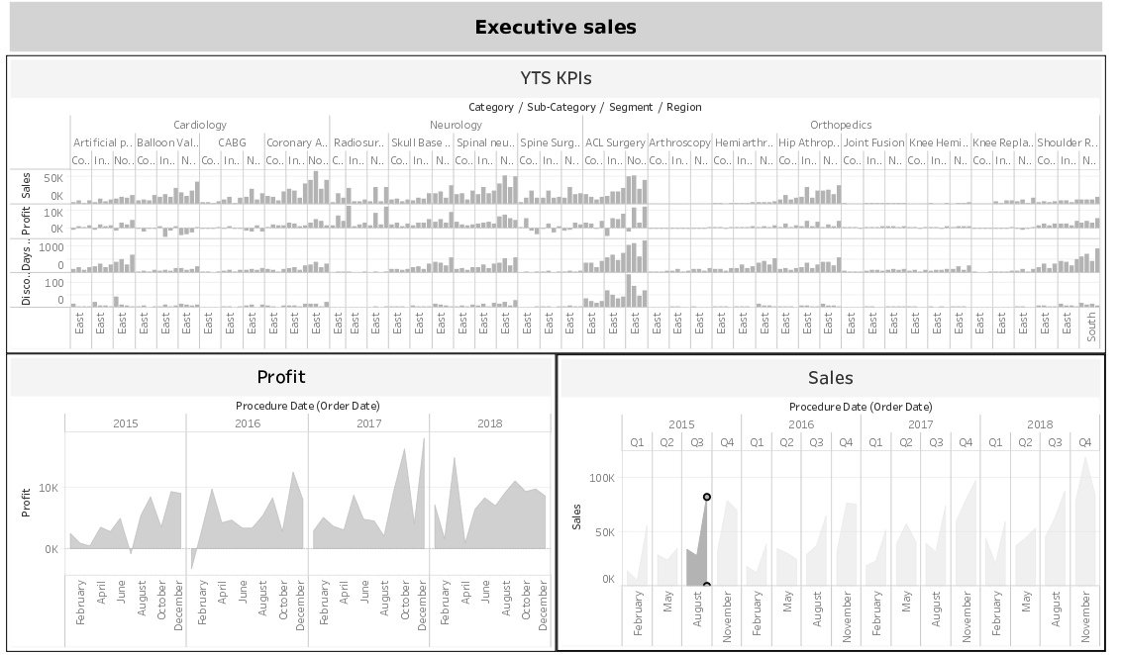

**YTS KPI – The First Chart**

The first chart, titled "YTS KPIs," presents key performance indicators related to total discount, overall profit, total quantity, and total sales

**Observations**

Here are the observations for each of these metrics:

**Total Discount**: The chart should display the total discount metric. It is important to consider the appropriate visualization type based on the nature of the data and the desired insights. For example, a bar chart or a stacked bar chart could be used to show the total discount values for different categories or time periods.

**Overall Profit**: The chart should showcase the overall profit metric. Similar to total discount, the choice of visualization should effectively convey the profit figures. Line charts, area charts, or a combination of different chart types could be used to present the overall profit trend over time or by different segments.

**Total Quantity**: The chart should visualize the total quantity metric. Depending on the nature of the data, a bar chart, pie chart, or bubble chart could be employed to represent the distribution or comparison of total quantity across categories or segments.

**Total Sales**: The chart should depict the total sales metric. Similar to total quantity, various visualization options such as bar charts, line charts, or area charts can be utilized to showcase the sales figures over time or by different dimensions.

To enhance the clarity and effectiveness of the "YTS KPIs" chart, appropriate labeling, axis titles, and legends to provide context and aid interpretation. Additionally, the chart is properly formatted and visually appealing with clear distinctions between different metrics.

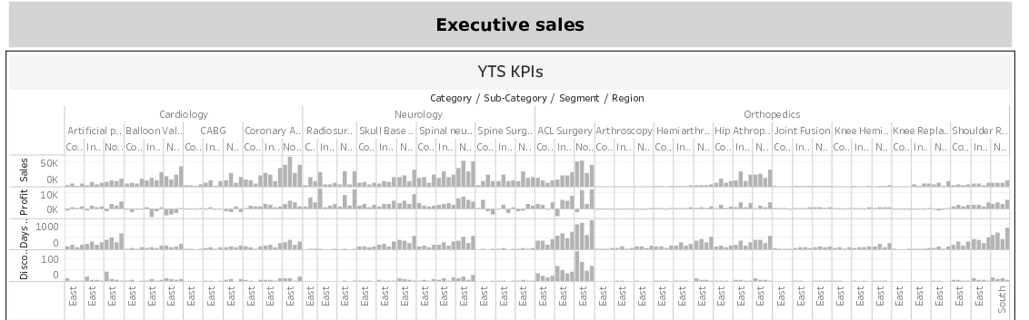

Top of Form

Bottom of Form

**Sales- The Second Chart**

The second graph, titled "Sales," aims to display monthly sales per year using an area chart with proper formatting.

**Observation**

* **Title**: The chart should have the title "Sales" to clearly indicate the purpose of the visualization and the metric being presented.
* **Monthly Sales**: The chart should illustrate the monthly sales figures for each year. An area chart is recommended for this purpose, as it effectively represents the cumulative sales over time and allows for easy comparison between different months and years.
* **Axis Labels**: The chart should have properly labeled axes, with the x-axis representing the months and the y-axis representing the sales values. Ensure that the labels are clear, legible, and appropriately scaled to provide accurate information.
* **Yearly Comparison**: The chart should enable the comparison of sales across different years. This can be achieved by using different colors or shades within the area chart to represent each year's sales data. A clear and consistent color scheme should be employed to ensure easy differentiation between the years.
* **Formatting**: The area chart should be properly formatted to enhance its visual appeal and clarity. This includes using appropriate line thickness, color gradients, and shading to effectively depict the sales trends and patterns over time. It is important to ensure that the formatting choices align with the overall aesthetics of the dashboard.
* **Interaction and Drill-down**: Consider incorporating interactive features in the chart that allow users to interact with the data, such as hovering over data points to display specific sales values or enabling drill-down functionality to explore monthly sales in more detail.

By following these observations, the "Sales" chart can effectively communicate the monthly sales trends per year, providing users with valuable insights into the sales performance over time.

Top of Form

Bottom of Form

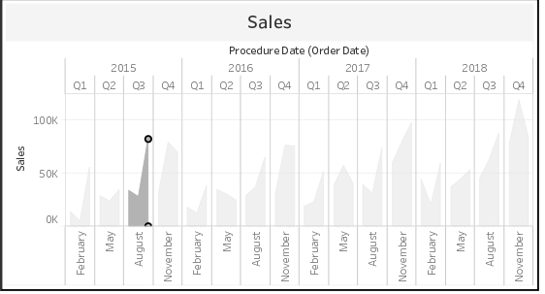

**Profit- The Third Chart**

The third graph should have the title "Profit" and display monthly profit per year using an area chart with proper formatting.

**Observation**

* **Title**: The chart should be titled "Profit" to clearly indicate the focus of the visualization and the metric being presented.
* **Monthly Profit**: The chart should showcase the monthly profit figures for each year. An area chart is recommended as it effectively illustrates the cumulative profit over time and facilitates easy comparison between different months and years.
* **Axis Labels**: The chart should have well-labeled axes, with the x-axis representing the months and the y-axis representing the profit values. The labels should be clear, legible, and appropriately scaled to provide accurate information.
* **Yearly Comparison**: The chart should enable users to compare the profit across different years. This can be achieved by using distinct colors or shades within the area chart to represent each year's profit data. Consistent color coding should be used to ensure clarity and easy differentiation between the years.
* **Formatting**: Proper formatting of the area chart is crucial for enhancing visual appeal and clarity. This includes selecting appropriate line thickness, color gradients, and shading techniques to effectively depict profit trends and patterns over time. The formatting choices should align with the overall aesthetics of the dashboard.
* **Interaction and Drill-down**: Consider incorporating interactive features in the chart to allow users to interact with the data. For example, users can hover over data points to view specific profit values or enable drill-down functionality to explore monthly profit in more detail.

By implementing these observations, the "Profit" chart can effectively convey the monthly profit trends per year, providing valuable insights into the profitability of the business over time.

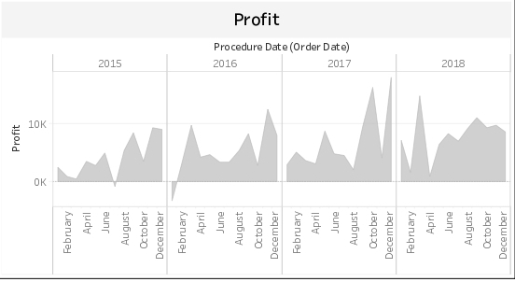

**CONCLUSION AND FUTURE SCOPE**

**Conclusion:**

The project of creating a dashboard in Tableau has been successfully completed, fulfilling the specified requirements and objectives. The dashboard provides valuable insights and visualizations for analyzing sales, discounts, profit, and quantity data. By leveraging the power of Tableau's data visualization capabilities, complex data has been transformed into actionable business insights.

The project has demonstrated the effectiveness of using Tableau as a tool for data visualization and analysis. The dashboard allows users to easily navigate and interact with the data, making it user-friendly and accessible to a wide range of stakeholders.

The project has also highlighted the importance of proper data collection, importing, and database design to ensure accurate and reliable visualizations. The use of appropriate chart types, formatting, and labeling has enhanced the clarity and effectiveness of the dashboard.

**Future Scope:**

* While the current project has successfully met the specified requirements, there are opportunities for further enhancement and expansion in the future. Some potential areas for future scope include:
* Integration of real-time data: The dashboard can be enhanced by incorporating real-time data feeds, allowing users to monitor and analyze sales, discounts, and profit trends in real-time.
* Advanced analytics: The inclusion of advanced analytics techniques, such as predictive modeling or forecasting, can provide deeper insights into future sales and profitability trends.
* Drill-down capabilities: Implementing drill-down functionality can enable users to explore the data at a more granular level, such as analyzing sales and profit by product category or customer segment.
* Mobile-friendly design: Optimizing the dashboard for mobile devices can extend its accessibility and usability, allowing users to access and analyze data on-the-go.
* Collaboration and sharing features: Implementing features that enable users to collaborate, share, and export visualizations can facilitate data-driven decision-making and knowledge sharing among stakeholders.

By incorporating these future scope enhancements, the dashboard can continue to evolve and provide more comprehensive and powerful insights for business analysis and decision-making.

Top of Form

Top of Form

Top of Form